Dear Parents of Grade 5 Students,
Welcome back to another great year of learning at Guthrie School. I welcome you and your child to the excitement of grade 5. Presently, there are 23 students in the classroom. Since we are in grade 5, I rely upon the students’ maturity, willingness to work collectively, the ability to try their best, and willingness to support each other throughout the year.
I will be teaching all the core subjects as well as art, physical education, computers, and health to the students. The following subjects will be taught by these others teachers.
Mrs. Murray-French (two blocks per week)
Mrs. Oltsher-Music (two blocks per week)

Core Subjects:
Language Arts: The following strands are covered in grade 5:
Explore thoughts and ideas
Comprehends various kinds of text
Manages ideas and information
Communicates clearly
Respects and supports others

Our main student anthologies used include Cornerstones (Gage Learning,) Communication Skills (Heath Canada Ltd.), and Working Words in Spelling (Houghton Mifflin Co.)

The students are involved in a variety of literature lessons necessary to enhance their reading, writing, listening, viewing, speaking and responding skills. Lessons on grammar, reading a variety of genre, studying high frequency words in spelling, partaking in guided reading groups, and writing different stories throughout the year will be our focus.

Math: The following strands are covered in grade 5:
Patterns and Equations
Whole Numbers
Multiplying and Dividing Whole Numbers
Measurement
Fractions and Decimals
Geometry
Statistics and Probability
Transformations

The student text book used most regularly is Math Makes Sense (Pearson) teacher created worksheets, “Mathletics” computer program.

Science: The following stands are covered in grade 5:

Weather Watch
Classroom Chemistry
Electricity
Mechanisms Using Electricity
Wetlands

Students partake in teacher created assignments and hands on learning experiences.

Social: The following strands are covered in grade 5:

Exploring Canada’s Regions
Canada Our Country (Confederation to present)
Current Events

The student textbook used most often is Voices of Canada-People, Places and Possibilities (Pearson).

Homework: Some days, the students will have some homework, necessary for catching up, review and practice of lessons taught in class. If there is no homework assigned, students can always review their notes, read a book, or practice their times tables. Students will make use of their daily agendas to record homework in. I will initial the agenda each day to ensure homework and special notes are copied down. I ask that you also initial the agenda to ensure that homework is complete and that communication has been reached back home.

Assignments/Evaluation: For the past several years, Guthrie School has implemented an online computer program, Power School, to document your child’s assignments, tests, and quizzes. Some of the student’s work will be used for learning and other work will be used for formal evaluation. Marks can come from a variety of repertoire: projects, quizzes, tests, notebooks, participation, interviews, anecdotal, checklists, etc. See description in Power School to check out the various weighting of each assignment for each subject area.
The school office has provided you with a login and password for Power School. If you do not have one or forgot your password, please contact the office at 780-973-3111 for a refresher.

Core subject marks will be based on a 5-point scale.
5-Student demonstrates an excellent performance and understanding of the learner outcomes by extending his/her learning and applying his/her knowledge.

4-Student demonstrates a consistent performance and a proficient understanding of the learner outcomes.

3-Student demonstrates an acceptable performance and a basic understanding of the learner outcomes.

2-Student demonstrates a developing understanding of the learner outcomes.

1-Student is experiencing difficulty meeting the learner outcomes.

Social Skills and Development marks are based on the following criteria:
C-Consistent
U-Usually
S-Sometimes
N-Needs improvement

Non-core subjects (Physical Education, Art, French, and Music) are based on the following criteria:

E-Excellent performance and understanding
A-Acceptable performance and understanding
N-Needs to improve performance and understanding

Marks are inputted into the computer on a regular, monthly basis. Marks can fluctuate based on the work assigned and the weighting given for each assignment. Final reporting grades will be established to include a first term parent-teacher interview in November, a second term parent-teacher interview in April and a third term, final report card, in June.
Fieldtrips: Our students certainly look forward to learning unique ways during our yearky fieldtrips. This year, we plan to attend Telus World of Science, Servus Place Swimming, Birch Bay Ranch, Skiing, and touring the Canossa Wetlands. Guthrie School always appreciates parent helpers on any of our trips. If you are available to assist, please let me know. Please note, the school requires a criminal record check to volunteer. If you have any questions, please contact the office for further information of school policy. (780-973-3111)
Staff Meetings: Our professional development days are scheduled throughout the year. Please check the sturgeon web page/calendar to verify dates. www.sturgeon.ab.ca
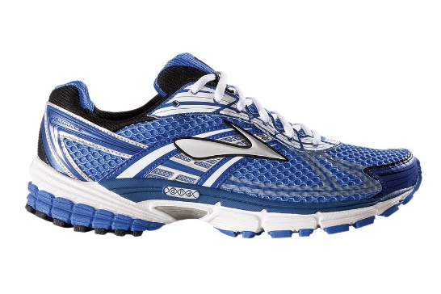
Indoor/Outdoor Shoes: Please ensure your child has a pair of running shoes for the gym. We change our shoes from outdoor to indoor to help keep our school clean and our socks dry. From past experience with our students in knee and foot pain, students are encouraged to wear running shoes rather than skateboarding shoes during gym class. In division II, we tend to play games and partake in activities that are more conducive to team sports. (Volleyball, track, football…)

Physical Eduation: The students are encouraged to change for gym. Students can make use of the locker in the gym for the time they are in the gym. PT gear can be stored in the classroom on our coat hooks. Students partake in gym 3 times a week.
Library: The students will be able to exchange books every Tuesday afternoon.
Computers: Students learn through technology using the computer lab. ipads and chrome books. Students are scheduled for computers 1-2 times per week.
To you, as partners in your child’s education, I thank you for your support and I look forward, with great enthusiasm, in working with your child this year. If you have any questions or concerns please make use of the agenda book or contact me at the school, 780-973-3111. Happy learning!
Sincerely,

Mrs. Quaghebeur

